

Spring 2026

Name: Adil Khan
Roll no: 2610-4011
Degree: BS AI

Task no 1:
#include <iostream>
using namespace std;

class Rectangle {
private:
double length;
double width;

public:
Rectangle(double l = 0, double w = 0) {
length = l;
width = w;
}

double area() {
return length * width;
}

double area(double l, double w) {
return l * w;
}

bool operator==(Rectangle r) {
return this->area() == r.area();
}
};

int main() {
Rectangle r1(5, 4);
Rectangle r2(2, 10);

cout << "Area of Rectangle 1: " << r1.area() << endl;
cout << "Area of Rectangle 2: " << r2.area() << endl;

cout << "Area using parameters (3,6): " << r1.area(3, 6) << endl;

if (r1 == r2)
cout << "Rectangles have equal area." << endl;
else
cout << "Rectangles do not have equal area." << endl;

return 0;
}

Output:
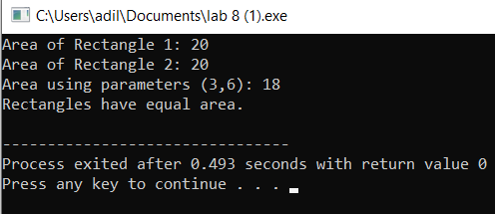

Task no 2:
#include <iostream>
using namespace std;

class Complex {
private:
double real;
double imaginary;

public:
Complex(double r = 0, double i = 0) {
real = r;
imaginary = i;
}

Complex operator*(Complex c) {
double r = (real * c.real) - (imaginary * c.imaginary);
double i = (real * c.imaginary) + (imaginary * c.real);
return Complex(r, i);
}

void display() {
cout << real << " + " << imaginary << "i" << endl;
}
};

int main() {
Complex c1(3, 2);
Complex c2(1, 7);

Complex result = c1 * c2;

cout << "Result: ";
result.display();

return 0;
}

Output:
